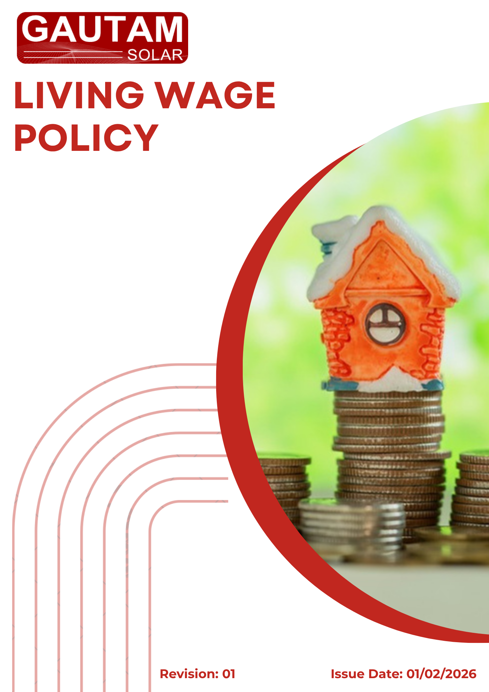

Contents
❖ Introduction 3
❖ Scope 3
❖ Policy Commitments 4
❖ Quantitative Targets & Qualitative Objectives 4
❖ Implementation Responsibility 6
❖ Monitoring and Review Mechanism 8
❖ Employee / Stakeholder Acknowledgment 9

- Introduction
Gautam Solar Private Limited believes that fair compensation is a fundamental human right and a cornerstone of decent work. The Company is committed to paying all its employees a living wage – defined as a wage sufficient to afford a decent standard of living for the worker and their family, including food, water, housing, education, healthcare, transport, clothing, and essential needs, plus a provision for unexpected events.
This policy aligns with the UN Guiding Principles on Business and Human Rights, ILO Convention No. 131 (Minimum Wage Fixing Convention) , the Global Living Wage Coalition framework, and SDG 8 (Decent Work and Economic Growth) , specifically target 8.5 on equal pay for work of equal value and decent wages.

- Scope
This policy applies to all employees directly employed by Gautam Solar Private Limited across all sites (headquarters, manufacturing plants, warehouses, and any other operational locations). It includes full-time, part-time, and fixed-term employees. Contractors, temporary workers, and third-party personnel are not covered by this direct policy, but the Company will encourage and work with suppliers to adopt living wage practices through its Living Wage Policy (by promoting the same principles in procurement contracts and supplier engagement).
Site | Location
Registered Office | D-120, Okhla Industrial Area, Phase-1, New Delhi-110020, India
Factory Unit 1 | Plot 67-70, Sec-8A, SIDCUL, Haridwar, Uttarakhand- 249403, India
Factory Unit 2 | 7 KM Milestone, Tosham Road, Bhiwani, Haryana-127032, India

- Policy Commitments
Commitment Area | Qualitative Commitment
Regular Benchmarking | Annually review the local living wage using credible external benchmarks (e.g., Anker methodology, Global Living Wage Coalition, or government-recognised estimates). Compare current entry-level wages to the benchmark and identify gaps.
Transparent Wage Structure | Publish internal wage bands and progression criteria. Ensure no discrimination in wage setting (equal pay for work of equal value regardless of gender, caste, religion, or other status).
Employee Consultation | Engage with employee representatives or unions in defining and updating the living wage definition. Conduct anonymous wage satisfaction surveys annually.
Annual Wage Adjustment | Commit to at least an annual cost-of-living adjustment (COLA) for all employees, even if the living wage benchmark has not changed significantly. Give priority to closing the gap for the lowest-paid employees.
Supply Chain Influence | Use the Company’s procurement processes to encourage tier-1 suppliers to commit to their own living wage roadmaps. Prefer suppliers that pay living wages or have time-bound targets.
Public Reporting | Publish an annual Living Wage Progress Report on the Company website, including coverage percentage, wage ratios, and benchmark comparisons.

- Quantitative Targets & Qualitative Objectives
(Baseline Year: FY 2023-24 | Target Year: FY 2030-31)
Sl. No. | Quantitative Target | Target (FY 2030-31) | Aligned SDG
1 | Percentage of direct employees paid a living wage | 100% | SDG 8.5
2 | Living wage gap reduction (difference between actual entry wage and verified living wage benchmark, as % of benchmark) | 0% gap (i.e., entry wage ≥ living wage) | SDG 8.5
3 | Frequency of living wage benchmark review | Annually (100% of years) | SDG 8
4 | Employee wage satisfaction Survey | Annually (100%) | SDG 8, SDG 3

- Implementation Responsibility
Human Resources (HR) Head
- Overall ownership of this policy.
- Conduct annual wage assessments against living wage benchmarks.
- Propose wage adjustments to Top Management and track implementation.
Finance Department
- Budget for living wage adjustments and ensure payroll accuracy.
Top Management
- Approve annual living wage budgets and adjustments.
- Review progress against all quantitative targets annually.
All Managers & Supervisors
- Ensure that wage-setting practices within their teams are non-discriminatory and transparent.
All Employees
- Provide honest feedback through wage satisfaction surveys.
- Report any concerns about wage fairness or discrimination to HR or the grievance mechanism.
- Monitoring and Review Mechanism
The Company shall monitor progress through:
- Annual living wage gap analysis conducted every Q1 of the fiscal year.
- Quarterly payroll audits to verify that all employees receive at least the applicable living wage.
- Annual employee wage satisfaction survey with results reported to Top Management.
This policy and its target shall be reviewed annually by the HR Head and Top Management.
Next review date: 01/02/2027
If external benchmarks increase faster than planned adjustments, the Company commits to a remediation plan to bring wages back to at least the living wage level within 12 months.
Approved By: _________________
Designation: _________________
Last Review Date: 01/02/2026
Next Review Date: 01/02/2027

- Employee / Stakeholder Acknowledgment
I hereby acknowledge that I have received, read, and understood the Living Wage Policy of Gautam Solar Private Limited.
I understand that the Company is publicly committed to paying a living wage to all direct employees by FY 2030-31, with specific quantitative targets.
I agree to:
- Cooperate with wage surveys and assessments as required.
- Report any concerns about wage fairness through the designated grievance channel.

Employee ID
Department
Designation
Location
Signature
Date

